1.1 Areas Between Curves Worksheet

- Find the area of the region enclosed by the curves and .

Find Intersections:

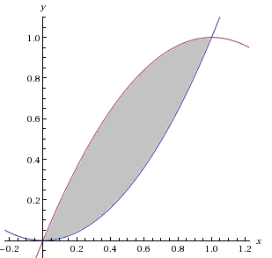
Setup:
$$\left(1,1\right)$$
$$\left(0,0\right)$$
Evaluate:

- Let R be the finite region bounded by the curves , and . Set up, but do not evaluate definite integrals which represent the area of the region R. Use your calculator to verify that both integrals produce the same value.
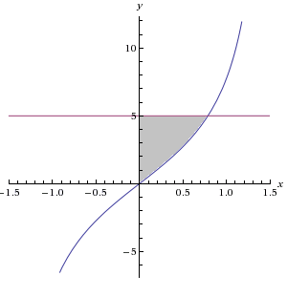
Find Intersections:
$$\left(0,0\right)$$
$$\left(0,5\right)$$
$$\left(\frac{π}{4},5\right)$$

- Integrate with respect to x.

Setup:

- Integrate with respect to y.

Solve equations for x:

Setup:

- Let R be the finite region bounded by the curves , , and . Set up, but do not evaluate definite integrals which represent the area of the region R. Use your calculator to verify that both integrals produce the same value.

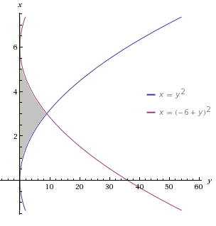
Find Intersections:
$$\left(9,3\right)$$
$$\left(0,0\right)$$
$$\left(0,6\right)$$

- Integrate with respect to x.

Solve equations for y:

Setup:

- Integrate with respect to y.

Setup:
Two integrals are needed here:

- Let R be the finite region bounded by the curves , , and .

- Determine the area of R by evaluating a definite integral with respect to y.

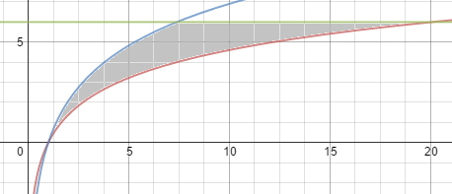
Find Intersections:
$$\left(e^{3},6\right)$$
$$\left(1,0\right)$$
$$\left(e^{2},6\right)$$

Solve equations for x:

Setup:

Evaluate:

- Set up, but do not evaluate, definite integral to represent the area of R by evaluating by integrating with respect to x. Use your calculator to see that this integral is equivalent to the one above.

Two integrals are needed here:
Setup:

- Let R be the finite region bounded by the curves .
- Determine the area of R by integrating with respect to x.

Find Intersections:
Points of Intersection:

Setup:

Evaluate:
- Determine the area of R by integrating with respect to y.

Solve equations for x:
Setup:
Evaluate:

- Find the of the region bounded by the curves and .
(Use your calculator to help find points of intersection and round decimals to 2 places)

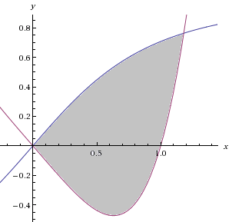
Find Intersections:
$$\left(1.18,y\right)$$
$$\left(0,0\right)$$

Setup:

Evaluate:
Let and thus .
Our limits of integration become: .

